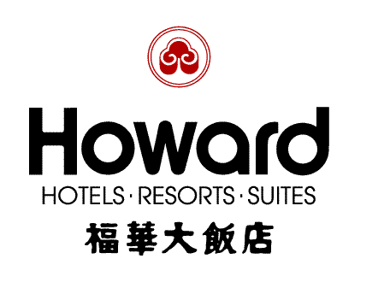
The 4th International Conference on Earthquake Engineering (4ICEE)
US-Taiwan Workshop on Smart Structural Technology for Seismic Hazard Mitigation
The 2nd Indo-Taiwanese Collaborative Workshop on Seismic Evaluation and Retrofitting of Building
The 3rd Across-the-Straits Conference on Earthquake Engineering (3ASCEE)

October 10- October 15, 2006
Hotel Reservation Form
Howard Hotels．Resorts．Suites offers special rates to participants of four Conferences to be held from October 10- October 15, 2006. To make your reservations, please complete the accompanying form with the appropriate information and return one copy by fax to 886-2-2708-2376 before September 10, 2006.
Attn：Amy Chen / Marketing & Sales Dept Tel：+886-2-2326-7527 Fax：+886-2-2708-2376

The Howard Plaza Hotel Taipei ( 160 Jen-Ai Road, Sec.3, Taipei )
Room Type | Superior Single | Superior Twin
Special Rate | NT$3,600+10%/room/night  (including one daily breakfast) | NT$3,900+10%/room/night  (including two daily breakfast)
Note 1:The above rates are valid from October 10- October 15, 2006
Note 2: The above rates are inclusive of complimentary benefits as follows:
*Fruit Basket *Daily Newspaper *One Welcome Drink / per person /per stay
*Free use of Health Club & Sauna
---------------------------------------------------------------------------------------------------------------------------------
Reservation information : (Please type or print clearly)
Guest Name :
Association/Organization: Title: _______________________________
Address : _________________________________
City：_________________Zip Code：________________ Country：____________________________
Tel：__________________Fax：____________________ E-mail：_____________________________
Number of rooms required: Superior King ________ Superior Twin _________
Arrival Date: Flight Details: Departure Date:
Check-in Date: Check-out Date:
Credit Card: □ Master Card □ Visa □ JCB □ AE □ Diners
Card No：□□□□ - □□□□ - □□□□ - □□□□ Expiry Date： （M） （Y）
Card Holder Signature:________________________________ Date：
Transportation Arrangement (Airport Pick Up) :
Limousine (NT$1,470 / car / trip 06:00-23:00, NT$1,680 before 06:00 or after 23:00 )
Number of persons

* Note1:The foreign exchange rate will be calculated according to the payment-date-rate.
* Note 2: Reservations and room allocation for any of the requested room types will be done on “First come, First serve” base along with the first night deposit. Please kindly provide your credit card details to guarantee your reservations. Any no-show or cancellation of reservations within 72 hours of the arrival date, one night deposit will not be refunded.

